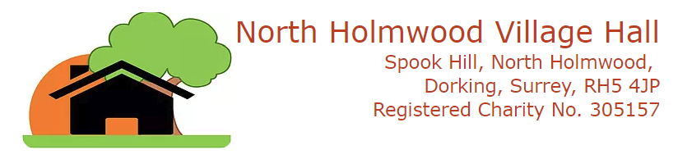

web: www.north-holmwood-village-hall.org.uk

Hire of Hall Ethics - HIRE TO COMPETING BUSINESSES

REGULAR HIRERS PROTECTION

North Holmwood Village Hall will endeavour to protect the business interests of companies and individuals who have a regular hire of the premises for the purposes of their business to the extent that:
- If the Bookings Secretary receives a request to hire the village hall by a business or individual for a purpose which is similar to that undertaken by a current regular hirer, the request will be passed to the Chairman and Deputy Chairman for review.
- The Chairman and Deputy Chairman will review the request and make a decision about the hire based on the following guidelines:

Guidelines for deciding whether to allow or refuse the hire:

Regular hire will normally be refused to a competitor wishing to hire the village hall where:
- the Chairman and Deputy Chairman decide that the purpose is so similar to that of an existing regular hirer as to be targeting the same market
- In making this decision the Chairman and Deputy Chairman will take into account the exact offering, day(s) of the week / time of day and targeted age groups / communities

One-off hire will normally be accepted providing:
- The Chairman and Deputy Chairman are satisfied that the purpose is not to undermine the business of an existing regular hirer

OCCASIONAL HIRERS PROTECTION

North Holmwood Village Hall will permit competitors of occasional hirers to hire the village hall without referral to the Chairman and Deputy Chairman.

LEAFLETS & FLIERS

North Holmwood Village Hall has a number of leaflet holders and notice boards for leaflets and fliers. Only
leaflets and fliers which pertain to services and events occurring at North Holmwood Village Hall or within
North Holmwood parish, or elsewhere but run by or in conjunction with organisations based at North
Holmwood Village Hall will be permitted to be displayed.

The notice boards and leaflet holders will be regularly checked by members of the Council of Management and any not satisfying these criteria will be removed.

This code of ethics is similar to that applied by other village halls in the Dorking area, and is operated
in order to maintain the diversity of use of the village hall and sustainability of services offered.

John Foskett (Chairman)

